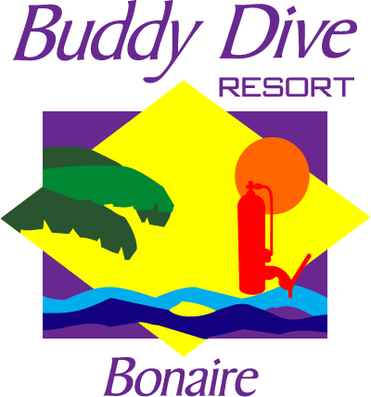
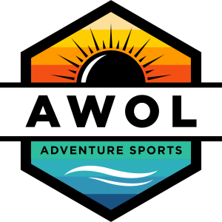
Dive Adventures with AWOL Adventure Sports
“A Way of Life”
Bonaire, Dutch Caribbean
General Information/ Terms & Conditions
Buddy Dive Resort

Dates: March 23rd – March 30th, 2024 ~SPRING BREAK!
Number of days: 8 days/7Nights
$2,485/pp Studio (double occupancy)
Cost: $2,588/pp One Bedroom Apartment (double occupancy) *based on current airline prices*
$2,369/pp Two Bedroom Apartment (quad occupancy)
Add $500 Single Occupancy
*Non-Divers Subtract $350 from price*
***PRICES ARE BASED ON CURRENT AIRLINE PRICES AND ARE SUBJECT TO CHANGE***
Deposits: A non-refundable deposit of $150.00/pp is required to confirm the space, no later than December 28th, 2018
Cancellations & Refund:
Fees will be charged accordingly when you cancel the reservation
> 3Months: Full refund minus $150 Non-refundable deposit
< 3Months: No Refunds
*Travel Insurance is recommended- please inquire about DAN
Package Includes: R/T Airfare out of BOI to BON
R/T Ground Transfers- BON Airport to Buddy Dive Resort
7 Night Accommodations in Beach front or Garden view apartments
Free Nitrox
6 Boat Dives (1-tank)
Unlimited Shore Diving- 6 days unlimited drive thru sair fills
Free breakfast daily
Truck Rental for the week (manual transmission, insurance not included, but required at the time of pick up)
Tanks, weights, weight belts are included with the diving
Government & Hotel Taxes included
Flights: Departure: TBD
Package Does Not Include:
Getting to/from Boise AIRPORT
Lunch & Dinner
Additional Dive Gear
Truck insurance (mandatory)
DAN Insurance
Dive Trip insurance (approximately 8% of trip cost, please inquire)
$25 Marine Park Fee
Tips for Dive Masters
Any items of personal nature

www.buddydive.com www.AWOL AdventureSports.com 208-735-5344

